US Education vs Salary over time

Hypothesis – There is a difference in wages over time based on education level, gender and race.

Project Description - Using the Wages by Education in the USA (1973-2022) data set found on Kaggle and sourced from the Economic Policy Institute’s State of Working America Data Library. We would like to determine if there are wage differences over time based on the criteria of education level, gender and race. The data has been adjusted for inflation.

Research Questions to Answer:

* Are salaries trending towards females earning as much as males for those with an advanced degree?
* Does the increase in education affect the increase in salary for both men and women equally?
* For those with an advanced degree, is there a difference between one of the groups based on race for the last 5 years?

Limitations:

All occupations are grouped together.

Data covers 50 years.

Data does not show experience that would increase hourly wage.

Question 1 - Are salaries trending towards females earning as much as males for those with an advanced degree?

For this question, data was obtained from the data set for total women and total men with advanced degrees. The statistics calculated for both Anova and Ttest are as follows:

Ttest: Statistic 9.947804941127643

PValue 4.1822362231788787e-16

DF 88.83363786823676

Anova: Statistic 98.95882314672339

Pvalue 1.5709388132185287e-16

For the ttest, the large statistic shows a large difference between the groups of men and women, and the small Pvalue (almost zero) suggests there is a statistically significant difference between the salaries of men and women.

For the Anova test, the Pvalue is once again very small, which suggests we can reject the null hypothesis. The large statistic shows the extent of this difference.

To show these values graphically, we first looked at a line chart of salary over the years for men and women individually. As noted below, there is a consistent gap over the years in salary between the genders, though in general it moves in the same directions.

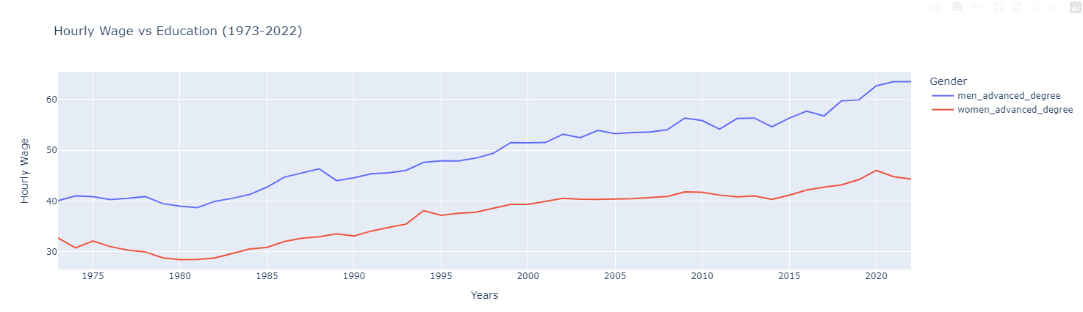

Next, we looked at a boxplot, which clearly shows a lower mean to the data of women compared to men.

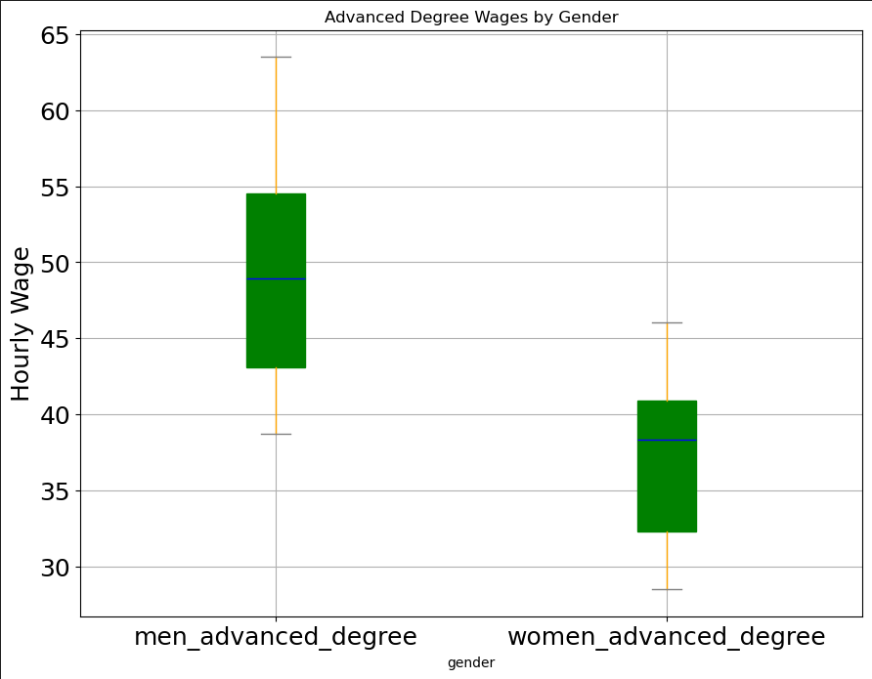

Finally, we created a histogram, which once again shows the mean of women and general trend is much lower than men.

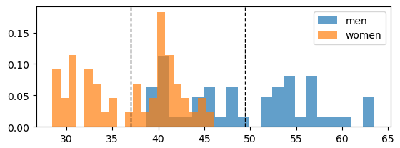

Question 2 - Does the increase in education affect the increase in salary for both men and women equally?

The average hourly wage of 50 years grouped by men and women with different education level are plotted on the graph above. As shown from the graph, men have a greater rate of increase then women for most education levels.

Taking a closer look at just the percent of increase with a high school degree. The histogram above shows a 1% difference in the rate increase for hourly wages.

The histogram below takes a closer look at the rate of change of hourly rate. There is about a 5% difference for men and women with men having a larger rate of increase.

Question 3 - For those with an advanced degree, is there a difference between one of the groups based on race for the last 5 years?

Conclusion:

The increase in education does not affect the increase in hourly wage for men and women equally. Men get a better rate of increase then women and the difference increases with higher education levels.